DESIGN TABLES FOR PRODUCT AND CATEGORY ENTITIES.
Project Title: Product Review and Rating Management System

Project Title : Product Review and Rating Management System
Student Name : Tamil raj M
Register Number : C4S38022
Department : B.Sc Artificial Intelligence
Course : Artificial intelligence (AI)
Academic Year : 2024 – 2027

1. Create Review and Rating Tables
CREATE TABLE Review (
review_id INT PRIMARY KEY AUTO_INCREMENT,
customer_id INT,
product_id INT,
review_text VARCHAR(500),
review_date DATE
);

CREATE TABLE Rating (
rating_id INT PRIMARY KEY AUTO_INCREMENT,
customer_id INT,
product_id INT,
rating INT,
rating_date DATE
);

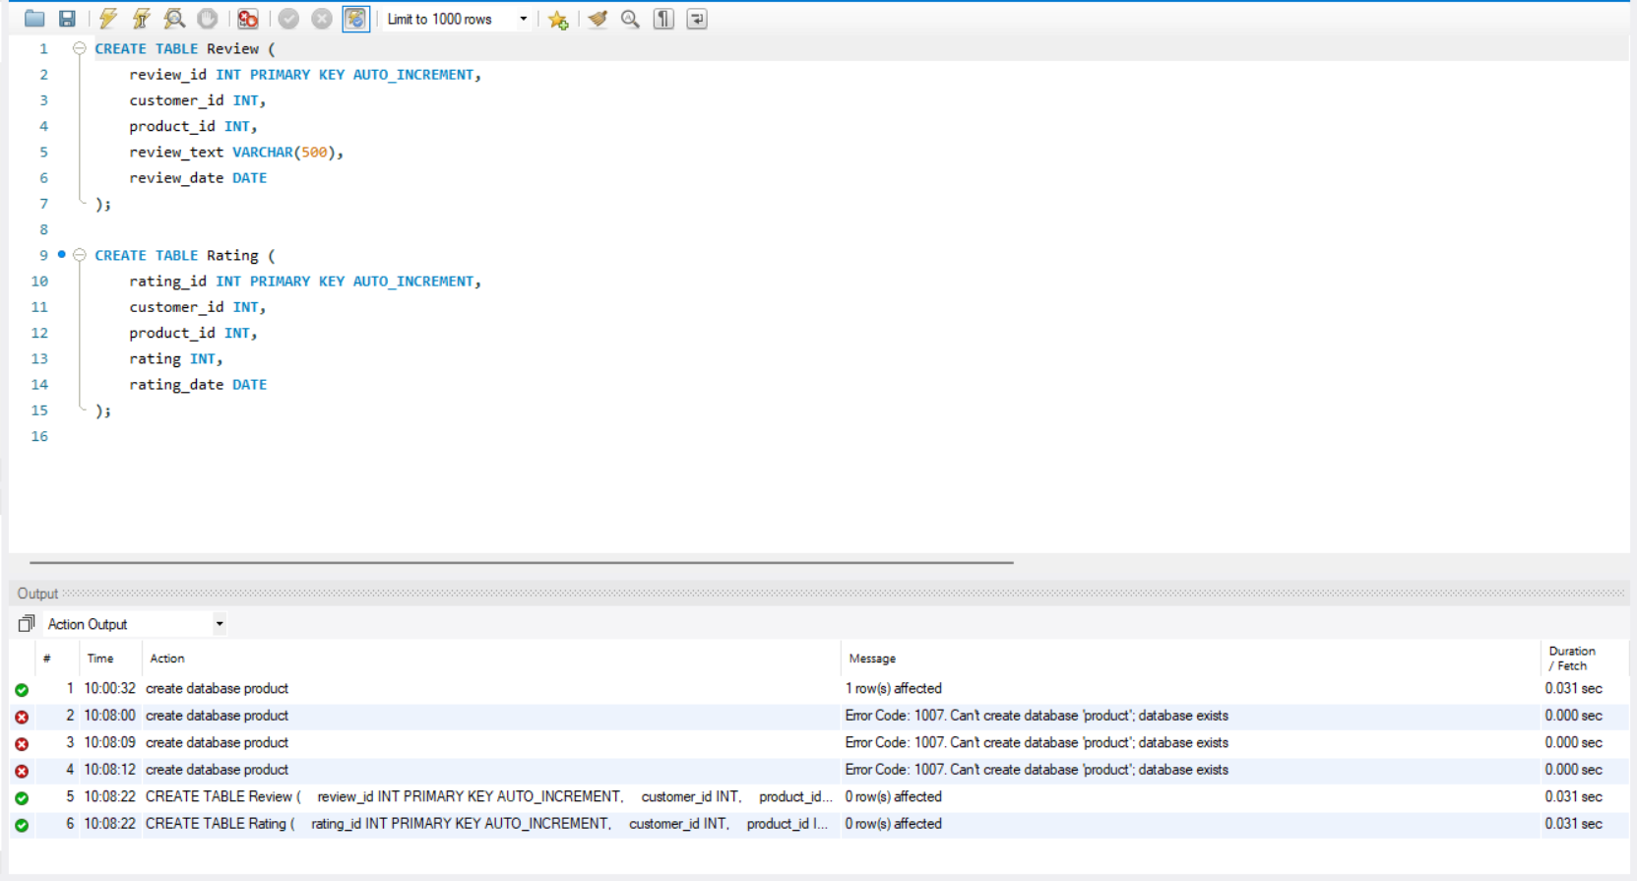

2. Store Customer Feedback and Ratings

INSERT INTO Review
(customer_id, product_id, review_text, review_date)
VALUES
(101, 201, 'Good quality product', '2026-08-20'),
(102, 201, 'Excellent product', '2026-08-20'),
(103, 202, 'Average quality', '2026-08-19'),
(104, 203, 'Very good product', '2026-08-18');

INSERT INTO Rating
(customer_id, product_id, rating, rating_date)
VALUES
(101, 201, 4, '2026-08-20'),
(102, 201, 5, '2026-08-20'),
(103, 202, 3, '2026-08-19'),
(104, 203, 5, '2026-08-18'),
(105, 203, 4, '2026-08-18');

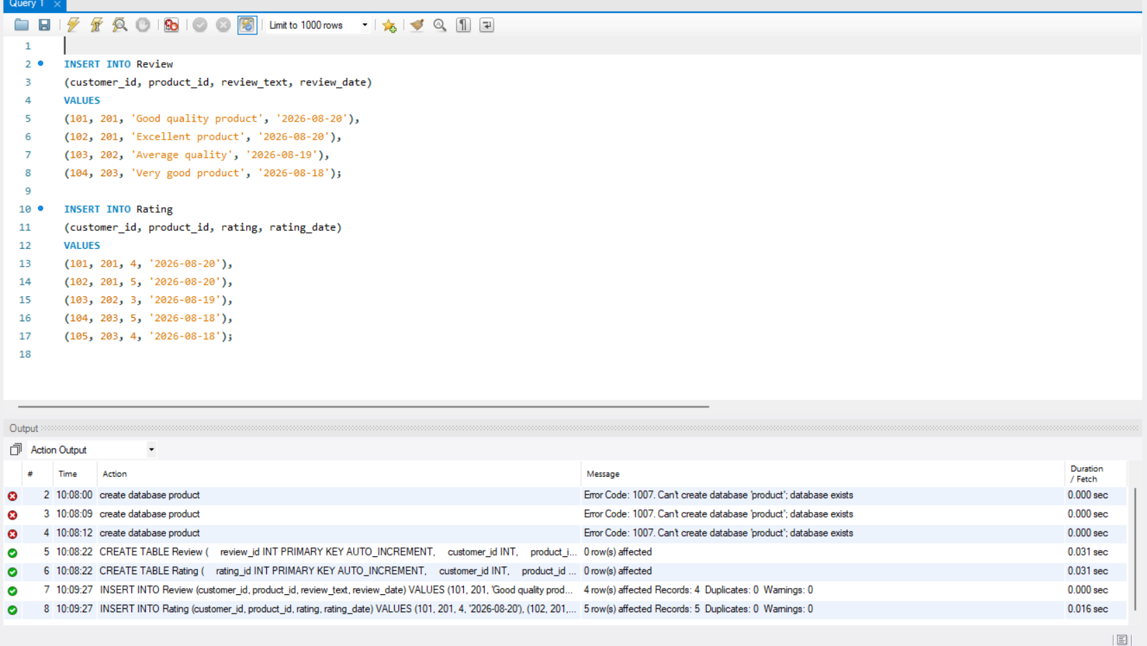

3. Retrieve Product Review Details

SELECT * FROM Review;

SELECT *
FROM Review
WHERE product_id = 201;
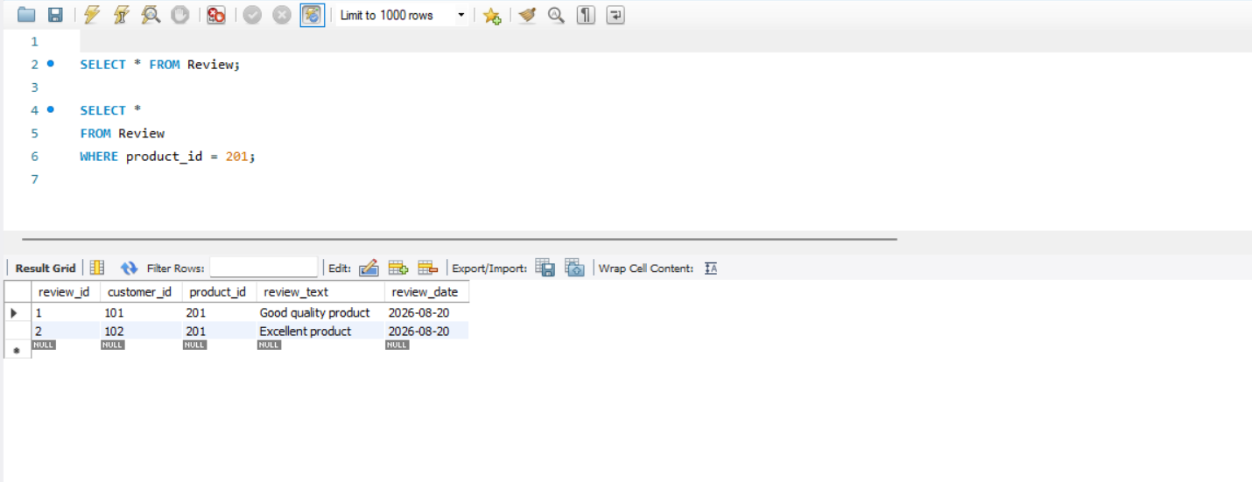

4. Calculate Average Product Ratings

SELECT
product_id,
AVG(rating) AS average_rating
FROM Rating
GROUP BY product_id;

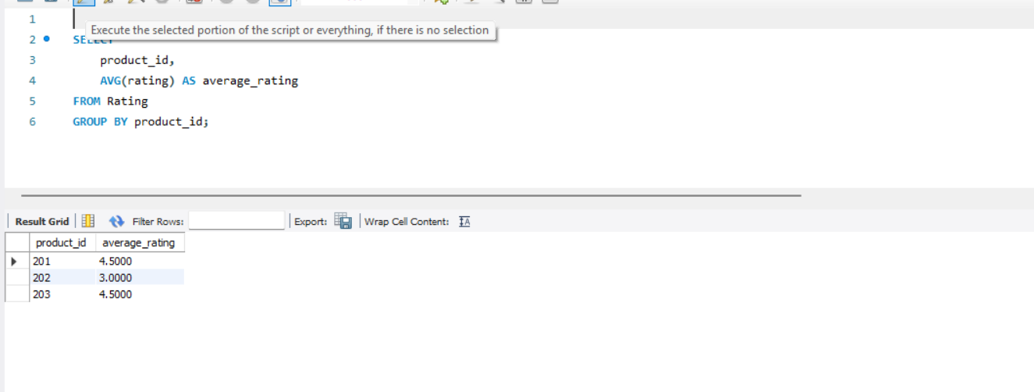

5. Identify Highly Rated Products

SELECT
product_id,
AVG(rating) AS average_rating
FROM Rating
GROUP BY product_id
HAVING AVG(rating) >= 4
ORDER BY average_rating DESC;

